***EXPERIMENT NO. 6 :- Design an obstacle detector and distance measuring device.***

**Circuit Diagram:-**

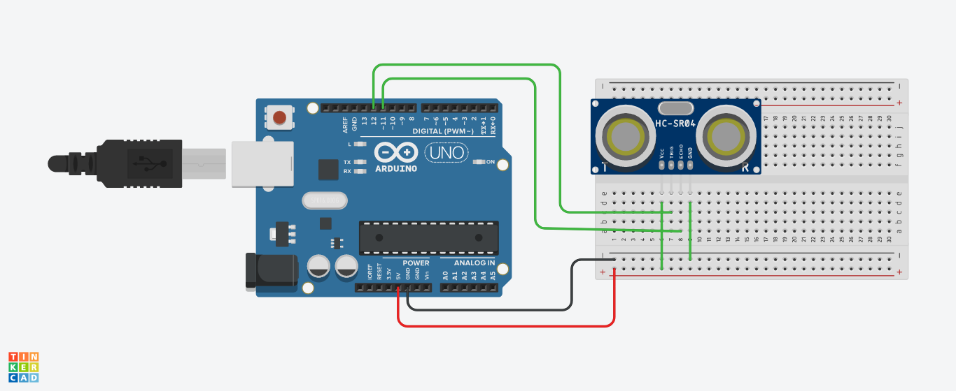

**Theory:**

**Concept Used:**

The concept used behind the realization of the above circuit is of sending and receiving signals. An ultrasonic sensor is a device that can measure the distance to an object by using sound waves . It measures distance by sending out a sound wave at the specific frequency and listening for that sound wave to bounce back . The time lapsed between sending and receiving signals is stored in a variable and divided by two. The time is multiplied by speed of sound to achieve the distance between the sensor and the obstacle.

**Learning & Observations:**

I learned how to make a distance calculating circuit using an ultrasonic sensor and the concept used behind making the sensor. The observation was that as we bring our hand closer to the sensor the distance being displayed on the serial monitor decreases .

**Problems & Troubleshooting:**

Problem faced during realization of the circuit was understanding the concept properly and implementing it to get the desired result. Focus and constant efforts helped in getting success .

**Precautions:**

* The sensor pins should be connected to appropriate ports of the Arduino.
* The wires should be properly inserted.

**Learning Outcomes:**

I learned how to use an ultrasonic sensor and the working principle behind it and also how to calculate distance of an obstacle using it.